Automation Script to make WF follow Status privileges as defined by Security Groups

The default behavior of Workflow is to ignore Security Group privileges for change status and other options. If a user who does not have Approve privilege on a Work Order in Security Groups gets a WO routed to them in WF for approval, WF will ignore the fact that the user does not have Approval privilege and allow the user to approve the WO. Maximo operates this way since the designer of the WF process specifically sent the WO to this user for approval so the approval is allowed. If the designer of the WF process did not want this user to approve the WO they would not have sent the WO to that user. This also allows the Maximo administrators the flexibility to remove the Change Status privileges from the users so that they cannot change the status in WOTrack but still can change the status using WF.

This automation script changes that default behavior. When this script is in place and active, WF will only allow the user to change the status if they have that status privilege granted to them in Security Groups. This script only changes Maximo's default behavior for status changes, WF will still ignore other Security Group options such as Create Workorder and allow a user who does not have Workorder (create workorder) in Security Groups to create a WO in WF using the application action CREATEWO.

Create a new Automation Script with Attribute Launch Point. For this example we will use PO for the Object, the Attribute is Status:

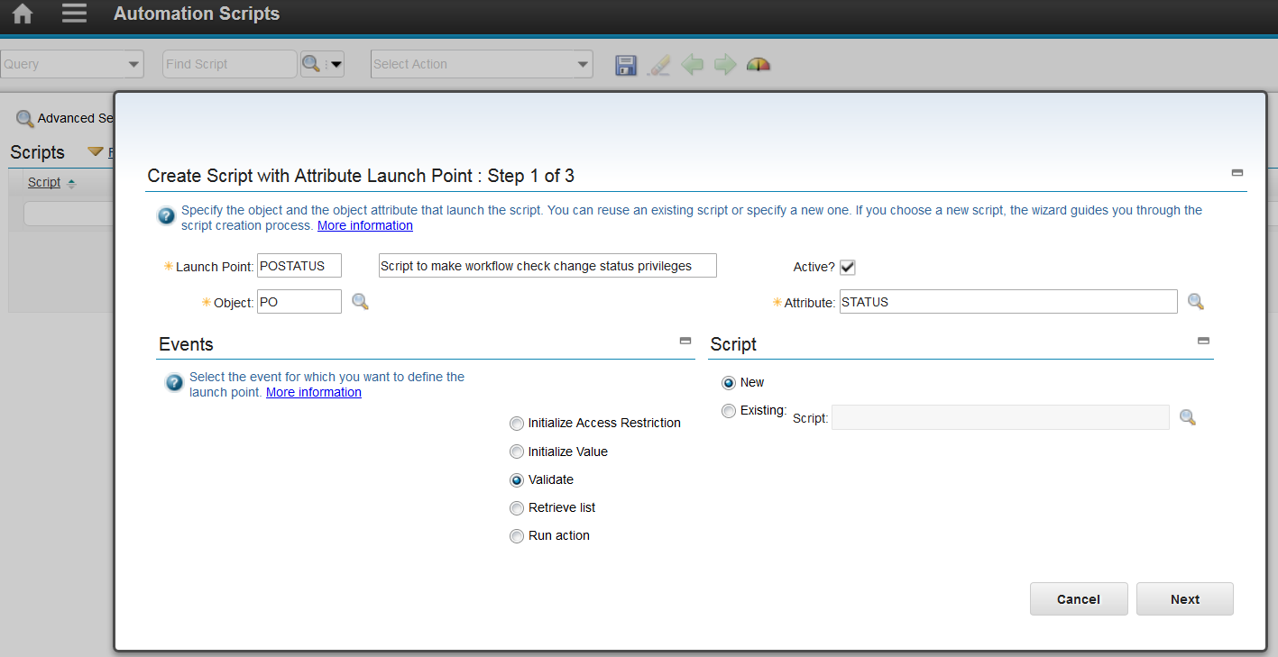

Step 2: Give the script a name such as WFSTATUS

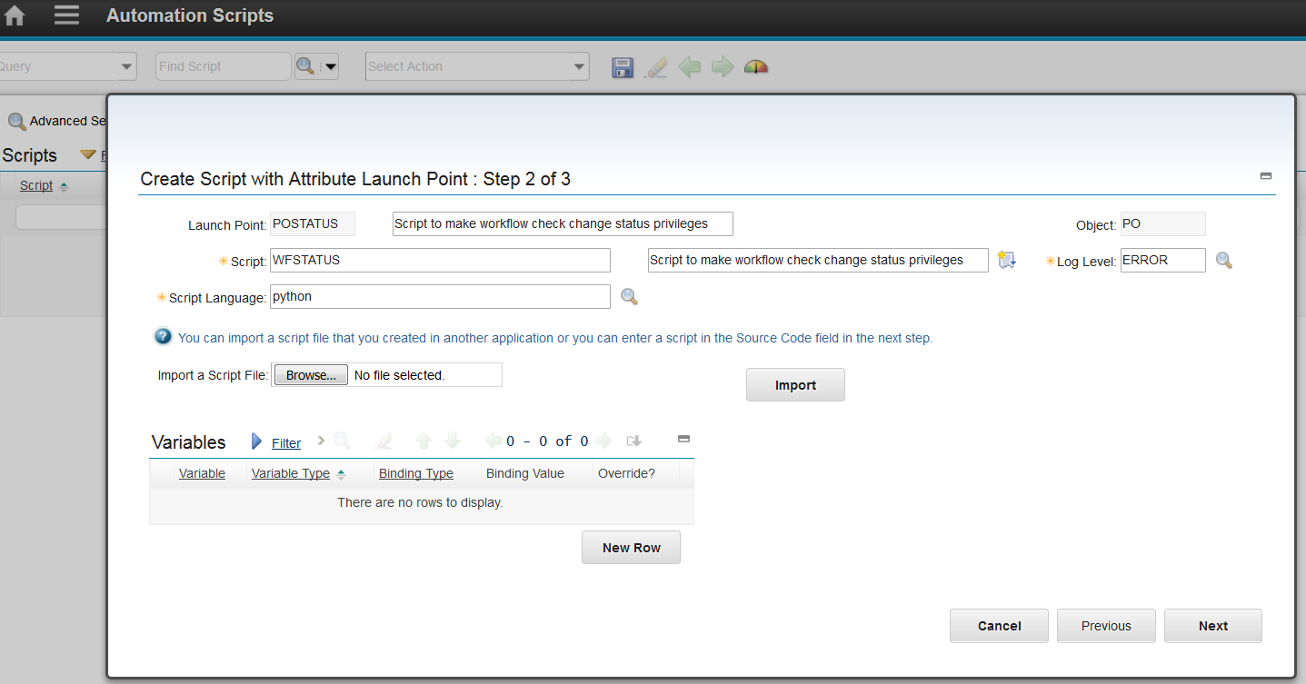

Step 3: Paste in the Source Code shown below

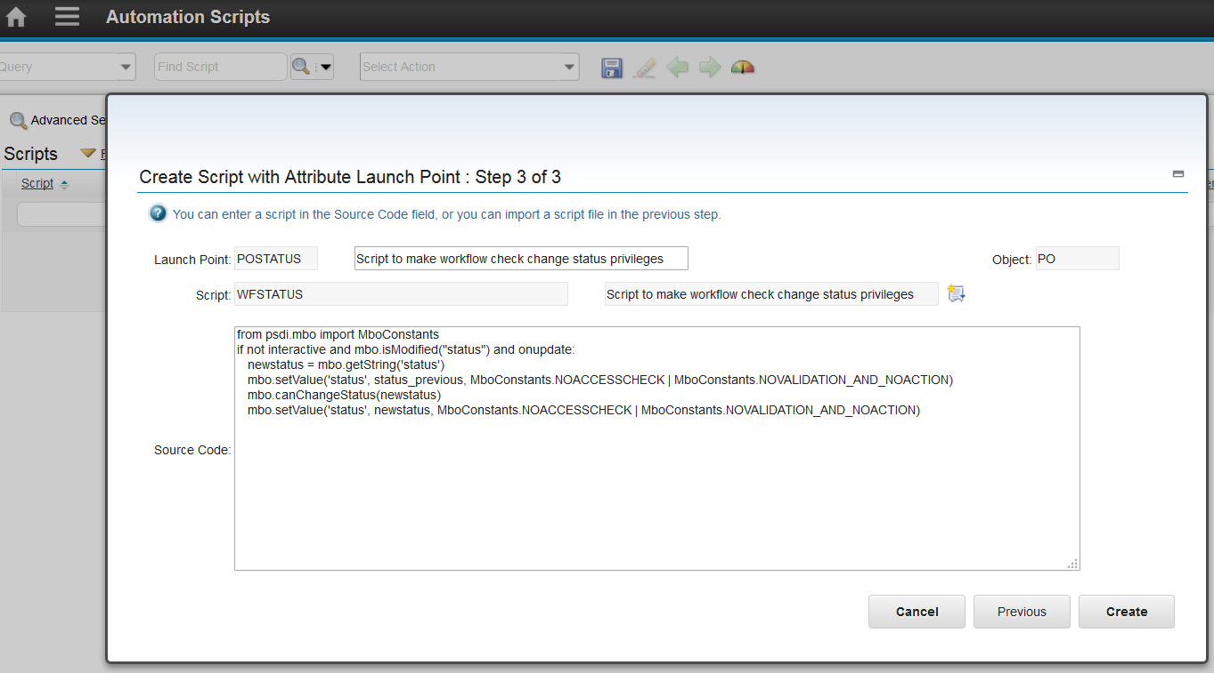

Script Source:

from psdi.mbo import MboConstants

if not interactive and mbo.isModified("status") and onupdate:

newstatus = mbo.getString('status')

mbo.setValue('status', status_previous, MboConstants.NOACCESSCHECK | MboConstants.NOVALIDATION_AND_NOACTION)

mbo.canChangeStatus(newstatus)

mbo.setValue('status', newstatus, MboConstants.NOACCESSCHECK | MboConstants.NOVALIDATION_AND_NOACTION)

|  |
| --- |
| The example above added the status privilege checking while in WF to PO. To add it to an additional Object, such as PR shown below, add an additional Launch Point from the List tab. Go to Create > Script with Attribute Launch Point. After filling in the Launch Point information, there is a radio button at the bottom to use existing script. Select Existing, fill in the Script name, WFSTATUS, and click Next: |

Click Next on Step 2 and Create on Step 3. No changes need to be made on those steps.

Automation Script tab:

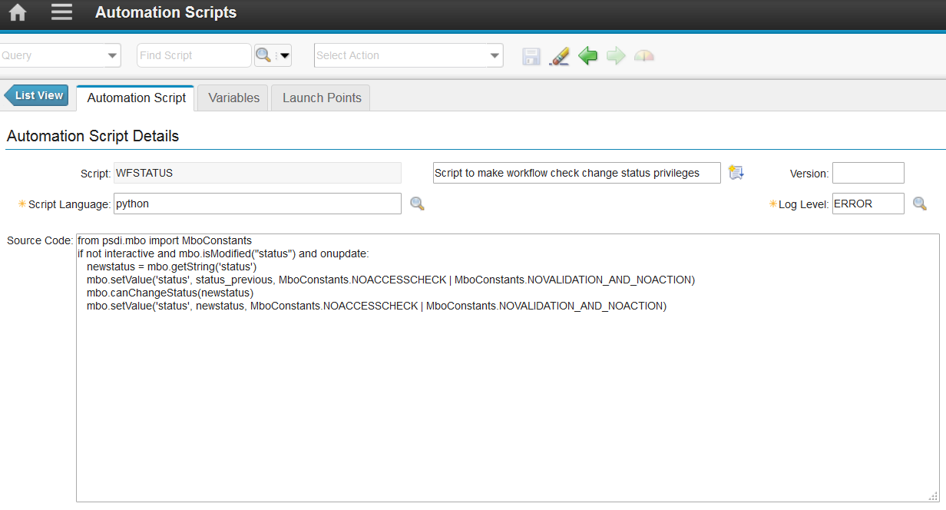

Variables tab:

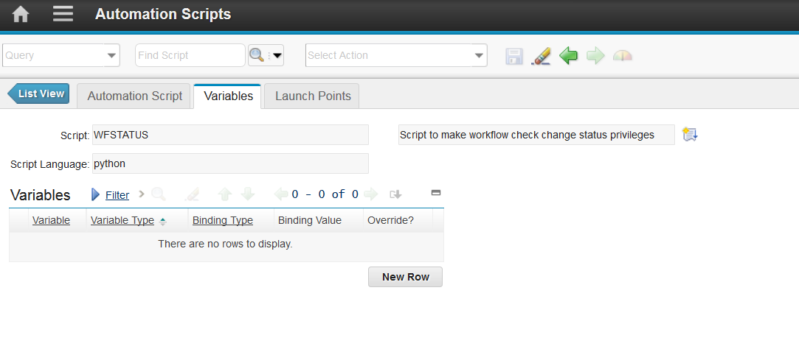

Launch Points tab (make one Launch Point for each Object you want to use this script with such as PR or WO):

